Advance Infantry Training Battalion – East:

Systems Engineering, Inc. Virtual Training Proposal



Technical Point of Contact: Dr. Roy L Hayes Jr.

Email: [Rhayesjr@seisecure.com](mailto:Rhayesjr@seisecure.com)

Phone: 571-434-6943

# Background

Systems Engineering, Inc. (SEI) and its partner Mid-Atlantic Defense Solution (MADS) are working with the Office of Naval Research to develop an artificial intelligence solution that learns winning strategies in previously unseen environments. Our goal is to develop better virtual opponents, which will augment the training of Marines. Improved virtual opponents reduce the need for ‘Pucksters,’ humans playing the opposing force, which lowers virtual training cost.

SEI and MADS have held previous discussions with the Advance Infantry Training Battalion – East and agreed to develop a virtual simulation that tests Immediate Action Drills, specifically danger area crossings and reactions to contact. Scenarios are currently limited to open terrain. Additionally, due to licensing constraints, SEI can only train four students at a time, limiting the scenario to the Fireteam or Squad level.

SEI is hoping to gain valuable data from the student’s playing through the scenario, which we will use to improve our algorithm. Additionally, we hope to foster a partnership where AITB-East is empowered to provide suggestions and feedback on additional training scenarios and requirements. We intend for this to be the first of many future virtual trainings.

# Scenario Limitations

SEI’s current AI has limitations, which limit the range of simulation possibilities. All limitations listed below are areas of research over the next year and will be addressed in turn. SEI welcomes any feedback on the relative importance of resolving each of these issues (i.e., Does AITB-EAST have suggestions on the areas SEI should focus on).

1. SEI has not tested its AI with human teammates. While it is possible to combine our AI solution with human teammates, unexpected behaviors are likely to occur.
2. License limitation prevents SEI from training more than four people at a time.
3. SEI’s AI solution is unable to navigate urban environments.

# Training Objectives

The virtual training will train students on crossing danger areas and taking contact from multiple directions and ranges. The map is the 'Geotypical Eastern Europe' map, which comes standard in Virtual Battle Space 3. SEI chose the map chip because its terrain closely resembles that found in Camp Lejeune (CLNC): low lying, relatively level terrain; wooded areas a varying density; large and small open areas; and significant linear danger areas. Additionally, SEI does not currently have access to digitized training maps of CLNC. SEI will use digitize training maps of CLNC in future virtual training events as they become available. The current training map with basic scenario details is included below.

As part of our initial train continuum, SEI will develop two smaller training scenarios that will build on each other and culminate in a larger patrol training scenario in a step wise progression. In the first training scenario, a Fireteam will navigate the danger area between checkpoints (CPs) 4 and 5. The Fireteam will perform this action twice during two discrete events, with an ambush occurring the second time. Instructors can provide feedback to the students between the first and second attempts. In the second scenario, a Fireteam will navigate the linear danger area located between CPs 6 and 7. Once again, the students will navigate the danger area twice, with an ambush occurring the second iteration. Instructors can provide feedback to the students between the first and second attempts.

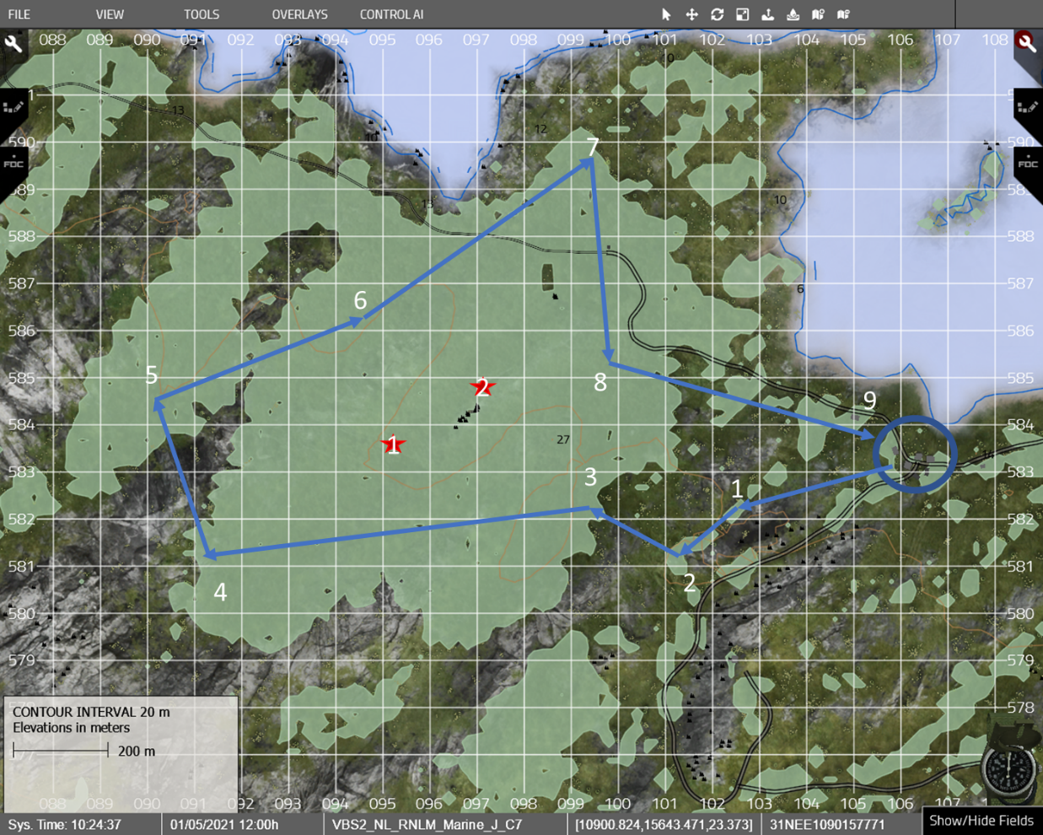

In the final training scenario, a Fireteam will generally follow the path depicted in the picture, though only because mission requirements will dictate that the assigned CPs be cleared in order. Students will start and finsih the patrol in the location circled in blue. It is important to remphasis that students will not be required to follow the blue path depicted in the map chip. We expect that some students may demonstrate creative pathing that allows them to negotiate the patrol in a safer, more effective manner.

During the patrol, students will be required to negotiate the relatively open terrain between the patrol base and CP 3, the open danger area (DA) between checkpoints 4 and 5, and the linear DA between CPs 5 and 7. Though student will be forced to cross the linear DA, they will have more flexibility with the open danger area encountered between CPs 4 and 5. Negotiating this terrain, the students will be forced to make a decision between: A) bypassing the DA (hooking north and around), but then being forced to backtrack across terrain they have already passed; or B) exposing the team to open terrain while crossing the DA, but thus eliminating the need to backtrack. Forcing this decision will train both students and the AI system on when and in what situations negotiating a DA is potentially perferential to bypassing it.

Additionally, two OPFOR buddy teams within the training area. These buddy teams will be controlled by SEI’s AI system and will begin the scenario in the wooded area at the center of the map (red stars 1 and 2). The OPFOR will be equiped with small arm only. OPFOR buddy team 1 will ambush the blue team patrol between checkpoints 2 and 6. The OPFOR buddy team 2 will ambush the patrol between checkpoint 6 and 8. At the start of each simulation, the OPFOR buddy teams will randomly select their respective ambush location sites. During some simulation runs, the ambush will occur at the danger area crossing, and, in others, the ambush will occur at some other point on the patrol route. This randomness is a critical component of system training and will allow students to play through the scenario multiple times without knowing where the ambushes will occur.

Throughout the described scenarios, students will be required to demonstrate their ability to negotiate danger areas and demonstrate their ability to effectively respond to ambush and chance contact. Students will learn and demonstrate the following skills:

1. Crossing a Linear Danger Area
2. Crossing Open Danger Areas
3. Reacting to Contact from the Front, Left, Right, and Rear
4. Reacting to Near Ambush

Moving forward, as both students and SEI’s AI system demonstrate comfort with the execution of this scenario at the fireteam level, the force sizes utilized will be gradually increased. This will allow for a progressive training model focusing for the students and allow time for the technical experimentation needed to ensure realistic outcomes when human and AI players are integrated into a collaborative team.

# Successful Result

Systems Engineering, Inc. will provide AITB-EAST with the same scenario using Virtual Battle Space 3’s built-in AI system. A successful result from the virtual training is listed below:

1. Students and Instructors find the virtual training valuable.
2. Students and Instructors rate SEI’s AI system more challenging than VBS 3’s AI system.
3. Students and Instructors rate SEI’s AI system more realistic than VBS 3’s AI system.
4. Students and Instructors find that SEI’s scenario has better replay ability (i.e., Students can play through the scenario multiple times and still find learning value in the scenario).